Life Cycle Plan (LCP)

Project Name: Leamos(TM)

Team No. 7

Team Members and Roles

Name | Primary Role | Secondary Role
Monty Shah | Project Manager | Life Cycle Planner
Pragya Singh | System Architect | Prototyper
Shantanu Sirsamkar | Requirements Engineer | Feasibility Analyst
Suchita Doshi | Prototyper | Operational Concept Engineer
Swapnil Savdekar | Life Cycle Planner | System Architect
David Wiggins | IIV&V | Off-campus Shaper

Version History
Date | Author | Version | Changes made | Rationale
09/28/11 | Swapnil Savdekar | 1.0 | - Identified Skills for each team member according to Role | - Initial draft for use with Leamos
10/07/11 | Swapnil Savdekar | 1.1 | - Update Sections 3.3 | - Updated after Evaluation
10/08/11 | Swapnil Savdekar | 2.0 | - Added Purpose, Status and Assumptions of LCP | - Updated for Core FC package
10/15/11 | Swapnil Savdekar | 2.1 | - Added milestones, deliverables, estimations | - Updated for draft FC package
10/18/11 | Swapnil Savdekar | 2.2 | - Added estimations in section 5 | - Project estimations calculated
10/23/11 | Swapnil Savdekar | 2.3 | - updated estimations for Architected-Agile and NDI-Intensive parts | - Updated for final FC package  - Project estimations are ready for 2 semesters
11/07/11 | Swapnil Savdekar | 2.4 | - Fixed bugs from ARB | - Updated for final FC package
11/21/11 | Swapnil Savdekar | 3.0 | - Updated 2.2, 3.1, 3.3 and 5 | - Updated for initial draft DC package
11/30/11 | Swapnil Savdekar | 3.1 | - Updated cost estimates with latest iteration from COTIPMO | - Updated for DCR ARB
12/05/11 | Swapnil Savdekar | 3.2 | - Updated project estimates and scale factors according to DCR ARB feedback | - Updated for DCP

Table of Contents
Life Cycle Plan (LCP) i
Version History ii
Table of Contents iii
Table of Tables iv
Table of Figures v
1. Introduction 1
1.1 Purpose of the LCP 1
1.2 Status of the LCP 1
1.3 Assumptions 1
2. Milestones and Products 2
2.1 Overall Strategy 2
2.2 Project Deliverables 4
3. Responsibilities 9
3.1 Project-specific stakeholder’s responsibilities 9
3.2 Responsibilities by Phase 9
3.3 Skills 12
4. Approach 14
4.1 Monitoring and Control 14
4.2 Methods, Tools and Facilities 15
5. Resources 16

Table of Tables
Table 1: Artifacts Deliverables in Exploration Phase 4
Table 2: Artifact Deliverable in Valuation Phase 5
Table 3: Artifact deliverable in Foundations Phase 6
Table 4: Artifact deliverable in Development Phase 7
Table 5: Stakeholder's Responsibilities in each phase 9
Table 6: Skills of team members 12
Table 7: Tools Used 15
Table 8: COTIPMO estimation factors 16
Table 9: Associate Factors of Application Point 18
Table 10: COCOMOII Scale Driver 20
Table 11: COCOMOII Cost Driver for Password Recovery Module 20
Table 12: COCOMOII Cost Driver for Data Migration Module 21

Table of Figures
No table of figures entries found.

    - Introduction

Purpose of the LCP
The purpose of Life Cycle Plan (LCP) is to serve as a guideline to monitor and control the project’s progress throughout all the phases of system development. It helps to plan and make best use of resources. It documents the system objectives, milestones and deliverables. It identifies the skills and responsibilities of each team member and the tools used for development of the system.

Status of the LCP
The LCP is currently at Development Commitment Package, version number 3.2. It contains details regarding the overall strategies used, resource and responsibility allocations, the time lines by which the deliverables have to be completed and the project estimates.

Assumptions
- The duration of the project is 24 weeks, of which 12 weeks are in Fall 2011 and 12 weeks are in Spring 2012.
- Development team consists of 6 members; 5 on-campus students and 1 DEN student.
- 2 members are continuing in 577b while other 4 members are not sure of taking 577b.
- Set of requirements will remain same throughput the life cycle
- Client will provide the integration between NDIs like Moodle and Course Merchant.
- Client is ready to pay, if required, for the tool to convert flash videos to HTML5.

    - Milestones and Products

Overall Strategy
This project uses NDIs such as Moodle, CourseMerchant and Flash to HTML5 converter. These NDIs provide some of the core functionalities required by the system. There are some modules which will be developed from scratch to provide additional functionalities to the system. The team has decided on following the NDI-Intensive Process with detailed architecture for development of Leamos(TM) project.

The project has currently been split into 6 phases which will be carried out over the period of 24 weeks and there are milestones and deliverables that have been assigned to each phase. They are as follows:
- Exploration Phase
- Valuation Phase
- Foundations Phase
- Re-baseline Foundations Phase
- Development Phase
- Operation Phase

These phases are as shown below:
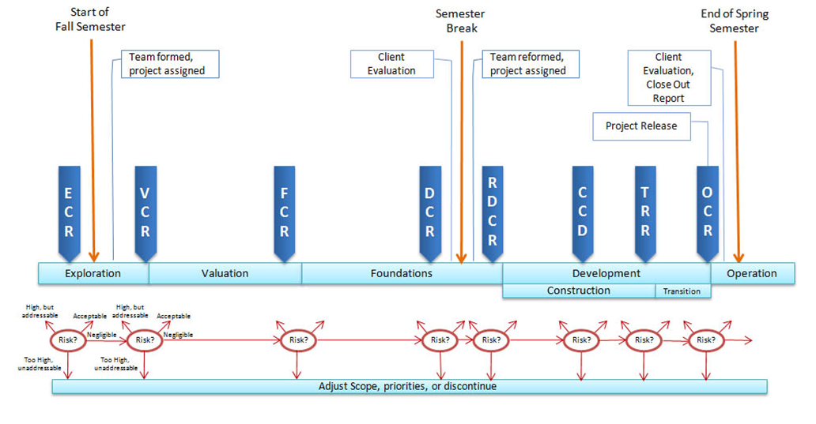

Exploration phase
Duration: 09/08/11- 10/03/11
Concept: This phase is to understand the project at hand, its basic requirements, explore all possible ways to build the system, and decide on the best amongst them. Team analyzed the current and proposed system, identified areas of development, project scope and risk issues.
Deliverables: Valuation Commitment Package
Milestone: Valuation Commitment Review
Strategy: One Incremental Commitment Cycle

Valuation phase
Duration: 09/28/11- 10/24/11
Concept: This phase builds project operational concept, win conditions, system and software architecture, and life-cycle plan. Team collaborated with client to know that win conditions and requirements and prioritized them. Team also created an initial prototype of the system capabilities and reviewed alternative solutions.
Deliverables: Initial Prototype, Report, Core Foundation Commitment Package, Draft Foundation Commitment Package
Milestone: Foundation Commitment Review
Strategy: One Incremental Commitment Cycle

Foundation phase
Duration: 10/25/11- 12/05/11
Concept: This phase finalizes the requirements after the second negotiation session with the stakeholders and builds a functional prototype that performs all the high risk functionalities required by the system.
Deliverables: QMP-I, QMP-II, Draft Development Commitment Package, Development Commitment Package,
Milestone: Development Commitment Review
Strategy: One Incremental Commitment Cycle

Re-baseline Foundations Phase
Duration: 01/09/12-02/11/12
Concept: This phase will recreate team and shared vision among all stakeholders. This phase will also review all the architecture, design, plan, artifacts and risks of foundation phase.
Deliverables: Re-baseline development commitment review package
Milestone: Re-baseline development commitment review
Strategy: Meetings

Development Phase
Duration: 02/15/12-05/07/12
Concept: This phase is to build upon the Functional Prototype developed in the Foundations phase. After completion we need to deploy this system to clients’ site and train the client on how to use the system. This phase has two iterations viz. construction iteration and transition iteration.

Construction Iteration
Duration: 2/15/12- 4/03/12
Concept: In this iteration, system prototyped during the first half of the life cycle will be developed. The implemented system will be tested according to test plan, defects from the testing will be fixed and system will be ready for deployment.
Deliverables: Transition readiness review package, Working system
Milestone: Core Capability Drivethrough
Strategy: Implementation and Testing

Transition Iteration
Duration: 4/04/12- 5/7/12
Concept: In this iteration system will be transitioned and installed at the client site, so that the clients and users of the system will be able to use it. Training will be provided to admins and maintainers at client site and user manual and video tutorials will be created. Then the system and training material will be handed over to the client.
Deliverables: Transition package, Operation Commitment Package
Milestone: Operation Commitment Review
Strategy: Transition, Training

Project Deliverables

Exploration Phase
Table 1: Deliverable Artifacts in Exploration Phase
Artifact | Due date | Format | Medium
Client Interaction Report | 9/21/2011 | .doc, .pdf | Soft copy
Valuation Commitment Package  - Operational Concept Description (OCD) Early Section  - Life Cycle Plan (LCP) Early Section  - Feasibility Evidence Description (FED) Early Section | 09/28/2011 | .doc, .pdf | Soft copy
Project Effort | Every Monday | Text | ER system
Project Plan | Every Wednesday | .mpp, .pdf | Soft copy
Progress Report | Every Wednesday | .xls | Soft copy

Valuation Phase
Table 2: Deliverable Artifacts in Valuation Phase
Artifact | Due date | Format | Medium
Initial Prototype Report | 09/28/2011 | .doc, .pdf | Soft copy
Evaluation of Valuation Commitment Package | 10/03/2011 | .xls | Soft copy
Win Report | 10/01/2011 | .doc, .pdf | Soft copy
Evaluation of Initial Prototype | 10/04/2011 | .doc, .pdf | Soft copy
Core Foundations Commitment Package:  - Operational Concept Description(OCD)  - System and Software Requirements Description (SSRD)  - System and Software Architecture Description (SSAD)  - Life Cycle Plan (LCP)  - Feasibility Evidence Description (FED)  - Supporting Information Document (SID) | 10/10/2011 | .doc, .pdf | Soft copy
Evaluation of Core Foundations Commitment Package | 10/12/2011 | .doc, .pdf | Soft copy
Draft Foundations Commitment Package:  - Operational Concept Description (OCD)  - System and Software Requirement Description (SSRD)  - System and Software Architecture Description (SSAD)  - Prototype  - Life Cycle Plan (LCP)  - Feasibility Evidence Description (FED)  - Supporting Information Document (SID) | 10/14/2011 | .doc, .pdf | Soft copy
Response to Core FCP evaluation | 10/14/2011
Evaluation of Draft Foundations Commitment Package | 10/17/2011 | .doc, .pdf | Soft copy
Project Effort | Every Monday | Text | ER system
Project Plan | Every Wednesday | .mpp, .pdf | Soft copy
Progress Report | Every Wednesday | .xls | Soft copy

Foundations Phase
Table 3: Deliverable Artifacts in Foundations Phase
Artifact | Due date | Format | Medium
Foundations Commitment Package:  - Operational Concept Description (OCD)  - System and Software Requirements Description (SSRD)  - System and Software Architecture Description (SSAD)  - Prototype Report  - Life Cycle Plan (LCP)  - Feasibility Evidence Description (FED)  - Supporting Information Document (SID) | 10/24/2011 | .doc, .pdf | Soft copy
Response to Draft FCP Evaluation | 10/24/2011
Evaluation of Foundations Commitment Package (FCP) | 10/31/2011 | .doc, .pdf | Soft copy
Draft Development Commitment Package:  - Operational Concept Description (OCD)  - System and Software Requirements Description (SSRD)  - System and Software Architecture Description (SSAD)  - Prototype  - Life Cycle Plan (LCP)  - Feasibility Evidence Description (FED)  - Supporting Information Document (SID) | 11/21/2011 | .doc, .pdf | Soft copy
Evaluation of Draft Development Commitment Package | 11/28/2011 | .doc, .pdf | Soft copy
Development Commitment Package:  - Operational Concept Description (OCD)  - System and Software Requirements Description (SSRD)  - System and Software Architecture Description (SSAD)  - Prototype  - Life Cycle Plan (LCP)  - Feasibility Evidence Description (FED)  - Supporting Information Document (SID) | 12/05/2011 | .doc, .pdf | Soft copy
Response to Draft Development Commitment Package Evaluation | 12/05/2011 | .doc, .pdf | Soft copy
Project Effort | Every Monday | Text | ER system
Project Plan | Every Wednesday | .mpp, .pdf | Soft copy
Progress Report | Every Wednesday | .xls | Soft copy

Development Phase
Table 4: Deliverable Artifacts in Development Phase – Construction Phase
Artifact | Due date | Format | Medium
Initial Operational Capability | 03/15/2012 | .doc, .pdf | Soft copy
Draft Transition Package  - Transition Plan (TP)  - User Manual (UM)  - Support Plan (SP)  - Training Materials  - Regression Test Package (RTP)  - Packaged Tools and Procedure (PTP) | 03/30/2012 | .doc, .pdf | Soft copy
Core Capability Drivethrough Document | 03/30/2012 | .doc, .pdf | Soft copy
Project Effort | Every Monday | Text | ER system
Project Plan | Every Wednesday | .mpp, .pdf | Soft copy
Progress Report | Every Wednesday | .xls | Soft copy

Table 5: Deliverable Artifacts in Development Phase – Transition Phase

Artifact | Due date | Format | Medium
Transition Package  - Updated Draft Transition Package | 04/15/2012 | .doc, .pdf | Soft copy
Operations Commitment Package  - Updated Development Commitment Package | 04/30/2012 | .doc, .pdf | Soft copy
Project Effort | Every Monday | Text | ER system
Project Plan | Every Wednesday | .mpp, .pdf | Soft copy
Progress Report | Every Wednesday | .xls | Soft copy
    - Responsibilities

Project-specific stakeholder’s responsibilities
The project has 5 major stakeholders: 1) client, 2) users, 3) maintainer, 4) development team and IIV&V, 5) USC SE Staff. Besides these there are no other project specific stakeholders.

Responsibilities by Phase
Table 5: Stakeholder's Responsibilities in each phase for 577a
Team Member / Role |  | Primary / Secondary Responsibility
 |  | Re-baseline Foundations Phase | Development Phase - Construction Iteration | Development Phase - Transition Iteration
Name: Monty Shah  Role: Project Manager / Life Cycle Planner | Primary Responsibility  - Detail Project Planning.  -Record Project Progress.  -Record Project Individual Effort.  Secondary Responsibility  - Identify Responsibilities and skills. |  | Primary Responsibility  -Detailed Project Planning  -Record Project Progress  -Gather Definitions  -Record Project Individual Effort.  Secondary Responsibility  -Identify Responsibilities and skills.  -Analyze Current System. | Primary Responsibility  -Detailed Project Planning  -Record Project  Progress  -Gather Definitions  -Record Project Individual Effort.  Secondary Responsibility  -Detail Project Plan
Name: Shantanu Sirsamkar  Role: Requirements Engineer / Feasibility Analyst | Primary Responsibility  -Assess and Plans to Mitigate risks.  -Analyze Current System.  -Record Project Individual Effort.  Secondary Responsibility  -Find out risk items |  | Primary Responsibility  -Assess and Plan to Mitigate Risks  -Explore Alternatives  -Provide Feasibility Evidence  -Gather Definitions  -Record Project Individual Effort.  -Assess Requirements Definition  -Develop Requirements definition  Secondary Responsibility  -Explore Alternatives | Primary Responsibility  -Assess Feasibility  Evidence  -Assess Requirements definition  -Gather Definitions  -Record Project Individual Effort.  Secondary Responsibility  -Assess Prototype and Components
Name: Pragya Singh  Role: Software Architect / Prototyper | Primary Responsibility  -Analyze Current System.  -Record Project Individual Effort.  Secondary Responsibility  -Prioritize capabilities  - Design prototype |  | Primary Responsibility  -Define Architecture,  Analyze the proposed system,  -Define Technology Independent Architecture,  -Feasibility Evidence,  -Specify Architecture Styles, Patterns and Frameworks environment.  -Gather Definitions  -Record Project Individual Effort.  Secondary Responsibility  -Assess Prototype and Components  -Explore Alternatives  - Prepare Development/production environment | Primary Responsibility  -Assess System Architecture, Define Technology- Dependent Architecture, Specify Architecture Styles, Patterns and Frameworks.  -Gather Definitions  -Record Project Individual Effort.  Secondary Responsibility  -Develop functional prototype  - Assess the prototype  - Get feedback from stakeholders
Name: Suchita Doshi  Role: Prototyper / Operational Concepts Engineer | Primary Responsibility  -Analyze Current System.  -Record Project Individual Effort.  Secondary Responsibility  - Explore the current system  - Develop goals, visions, and usage scenarios |  | Primary Responsibility  -Identify Objectives, Constraints and Priorities.  -Identify Shared Vision.  Establish New Operational Concept.  -Identify System Transformation.  -Identify Organizational and Operational Transformation.  -Explore Alternatives.  -Analyze the Proposed System.  -Identify Responsibilities and Skills.  -Identify Life Cycle Management Approach.  -Gather Definitions.  -Construct Traceability Matrix.  -Verify and Validate Work Products Using Issue (Defect) Tracking System.  -Record Project Individual Effort.  Secondary Responsibility  -Explore alternatives for system  - Establish new operational concept | Primary Responsibility  -Record Project Individual Effort.  -Assess Operational Concept.  -Construct Traceability Matrix.  -Verify and Validate Work Products Using Issue (Defect) Tracking System.  Secondary Responsibility  -Define detail operational concept  - Assess operational concept
Name: Swapnil Savdekar  Role: Life Cycle Planner / System Architect | Primary Responsibility  -Identify Responsibilities and skills.  -Analyze Current System.  -Record Project Individual Effort.  Secondary Responsibility  -Analyze Current System.  -Explore technology/NDIs |  | Primary Responsibility  -Assess Requirements Definition  -Develop Requirements definition  -Estimate effort and schedule using COCOMO/COTIPMO  -Identify Life Cycle Management Approach  -Identify Milestones and Products  -Identify Responsibilities and Skills  -Feasibility Evidence  -Gather Definitions  -Record Project Individual Effort.  Secondary Responsibility  -Define Architecture overview  -Model the system | Primary Responsibility  -Assess Life Cycle Content  -Assess Requirements definition  -Develop Transition Plan  -Identify Development Iteration  -Gather Definitions  -Record Project Individual Effort.  Secondary Responsibility  - Specify Architecture Styles, Patterns and Frameworks  - Analyze and assess NDI architecture
Name: David Wiggins  Role: IIV & V/Shaper | Primary Responsibility  - Facilitate WinWin negotiation  -Review VC package  Secondary Responsibility  -Assess risk |  | Primary Responsibility  -Verify and validate work products  -Report artifacts review  Secondary Responsibility  -Assess risks  -Shaper for WinWin | Primary Responsibility  -Evaluation of FC package  -Create QMP  Secondary Responsibility  -Assess risks  -Assess quality management plan and strategies

Table 6: Stakeholder's Responsibilities in each phase for 577b
Team Member / Role | Primary / Secondary Responsibility
Team Member / Role | Re-baseline Foundations Phase | Development Phase - Construction Iteration | Development Phase - Transition Iteration
Name: New Member  Role: Software Architect/Trainer | Primary Responsibility  Assess System Architecture  Secondary Responsibility  Identify training scenarios | Primary Responsibility  Integrate Components  Tailor Components  Develop Glue Code  Fix Defects  Secondary Responsibility  Prepare Training Plan | Primary Responsibility  Deploy the System  Fix deployment defects  Secondary Responsibility  Provide Training  Create Video Tutorial
Name: New Member  Role: Builder/Tester | Primary Responsibility  Assess System Architecture  Assess Operational Concept  Secondary Responsibility  Identify Traceability Matrix | Primary Responsibility  Develop Glue Code  Fix Defects  Integrate Components  Tailor Components  Secondary Responsibility.  Perform Testing | Primary Responsibility  Transition the System  Fix deployment defects  Secondary Responsibility  Perform Testing
Name: New Member  Role: Life Cycle Planner/Trainer | Primary Responsibility  Assess Life Cycle Content  Update Transition Plan  Identify Development Iteration  Secondary Responsibility  Identify Test Strategy | Primary Responsibility  Update Transition Plan  Identify Development Iteration  Secondary Responsibility  Create Training Plan | Primary Responsibility  Transition the System  Secondary Responsibility  Provide Training
Name: New Member  Role: Builder/QFP | Primary Responsibility  Integrate Components  Identify Traceability Matrix  Secondary Responsibility  Assess Quality Management Strategy | Primary Responsibility  Fix Defects  Implement Components  Secondary Responsibility  Perform Core Capabilities Drive-Through.  Assess Traceability Matrix. | Primary Responsibility  Transition the System  Secondary Responsibility  Assess Quality Management
Name: Monty Shah  Role: Project Manager/Builder | Primary Responsibility  Detailed Project Plan  Record Project Progress  Secondary Responsibility  Implement components | Primary Responsibility  Detailed Project Plan  Record Project Progress  Secondary Responsibility  Assess Development Iteration.  Perform Core Capabilities Drive-Through | Primary Responsibility  Perform transition  Secondary Responsibility  Fix testing defects
Name: David Wiggins  Role: Tester/QFP | Primary Responsibility  Identify Test Plan  Assess Quality Management Strategy  Secondary Responsibility  Identify Traceability Matrix  Configuration management | Primary Responsibility  Identify Test Plan  Identify Test Procedures  Perform Testing  Record Test Results  Secondary Responsibility  Assess Traceability Matrix.  Develop User Manual. | Primary Responsibility  Perform Testing  Record Test Results  Secondary Responsibility  Assess Quality Management

Skills
Table 7: Skills of team members

Team Members | Role | Skills
Monty Shah | Project Manager/Life Cycle Planner | Project Management, Team Coordination, Configuration Management, SVN, MS Project, SQL Management Studio, MySQL Workbench, C#, COCOMO II
Suchita Doshi | Prototyper/Operational Concept Engineer | PHP, HTML5, MySQL, Moodle, Eclipse, CourseMerchant, Quality Management
Swapnil Savdekar | Life Cycle Planner/System Architect | Quality Management, COCOMO, MS Project, HTML5, MS Visio, Balsamiq, Project Coordination, System Design, UML
Shantanu Sirsamkar | Requirements Engineer/Feasibility Analyst | Analysis, Negotiation, Assess and Evaluate requirements, SVN, MS Office, Skype, COCOMO II
Pragya Singh | System Architect/Prototyper | UML, PHP, MySQL, Balsamiq, HTML5, RSA, Project Coordination, System Design
David Wiggins | IIV&V/Shaper | WinWin Negotiation Facilitation, Evaluation and Assessment, Quality Assurance, Verification and Validation, BugZilla, Testing, PHP, UML

Skill requirements for new team members for 577b:
ROLE | SKILLS
Requirements Engineer | Analysis, Negotiation, Assess and Evaluate requirements, MS Office
Life Cycle Planner | Quality Management, COCOMO II, COTIPMO, MS Visio, System Design, UML
System Architect | UML, Balsamiq, RSA, Project Coordination, System Design
Prototyper | PHP, HTML5, Quality Management, Eclipse

    - Approach

Monitoring and Control
Monitoring and Controlling are primary aspects of a project. There are following 3 ways that we incorporate to monitor and control the progress of our project:

- Project Plan: We do plan our activities for a week during weekly meeting to have an idea where we need to be according the schedule. For this we use project plan, which is developed and maintained by the Project Manager and the Life Cycle Planner.

- Progress Report: It is very important to keep track of the progress made to help us monitor the progress the Project Manager makes a Progress Report every week. The progress report helps define what has to be done that week and check whether we achieved our goals for the week.

- Reviewing by IIV & V: IIV & V person participates in weekly meetings to decide on coming week tasks and plans. Also he reviews the work done by the team at every milestone/deliverable.

Closed Loop Feedback Control
Team members have weekly meetings. There are generally 2 meetings in a week. During these meeting team discusses the current progress of the project. They discuss on work already done, work to be done in future and plan for coming week’s work based on the schedule and each members’ availability. Team members also keep the issues in front of all members and discuss on solutions.
Team also reviews each other’s work and the documents that needs to be delivered to remove any errors and suggest improvements. Apart from meetings, team also communicates closely using mails.

Reviews
Reviews is an important part of the throughout the development of the project. Reviews help in correcting the errors, giving a direction to the development process and managing quality.
We are using below reviews to check the work done by each team member:

IIV & V Review: Each deliverable is thoroughly reviewed by IIV & V person who logs in all the bugs in BugZilla and assign to the respective member who worked on that deliverable. Each team member then checks these errors and corrects them and records his/her progress in BugZilla.

TA review: Each deliverable is checked and reviewed by TA. TA indicates all the flaws and comments on the deliverable. These are then checked by team members and corrected.

Peer Review: All the team members have weekly discussion on the project’s progress and plan for the future work. Also, before delivering the deliverable, each one is checked by members to check for any flaws and if found any, they are corrected and then submitted.

Client Review: Team has weekly meetings with client to discuss the project progress, issues, solutions and changes in the prototypes, schedule, etc.

Methods, Tools and Facilities
Table 8: Tools Used
Tools | Usage | Provider
Wallaby | For converting flash videos to HTML5 | Adobe
WinBook | To record win conditions, their issues and comments during negotiation meetings and discussions after meetings | USC
RSM | To create UML diagrams for software architecting of the project. | IBM
Bugzilla | For reporting bugs in deliverable artifacts by the IIV & V and for team to respond to these bugs with rationale on how they choose to act upon the bug. | USC
Microsoft Project | Used to help build the project plan. | Microsoft
Microsoft Visio | For drawing business flow diagram | Microsoft
Visual Studio 2005 | Used for programming in C# and ASP.net | Microsoft
My SQL Server | Used for implementation of the database | Apache
Skype | Used for Communicating with team members both; off campus and on campus | Skype Ltd.
Visual Paradigm for UML | Used for drawing Activity diagram | Visual paradigm
Google+ Hangout | For communication between team members both, off-campus and on-campus | Google
Balsamiq | For creating sales website prototype mock-ups | Balsamiq studios
Adobe Connect | Used for Communication between off campus and on campus students. | Adobe
iCARD | For documenting weekly efforts of each team member. | USC
COTIPMO | Used for Project Estimations | USC

Resources
Leamos(TM) project is using the NDI-Intensive Process Pattern along with Architected-Agile design. Development and project estimations are done using COTIPMO tool.

Estimations for modules using NDIs are done using the COTIPMO tool based on application points which take into account the number of screens, reports, and programming language.
Table 9: COTIPMO estimation factors

Screen name | Number of views | Number of source of data tables | Complexity level | Description
User page | 3 | 1 | Simple | This page has links for 3 different types of users, independent user, independent site and partner site who can enroll for the courses.
Partner site page | 5 | 1 | Simple | This page contains information to become a partner site and provides links for 3 registration packages i.e. 25, 50 or 75 students.
Independent site | 5 | 1 | Simple | This page contains information explaining how to become a partner site and provides links for 3 registration packages i.e. 25, 50 or 75 students.
Independent user registration page | 1 | 1 | Simple | This is the enrollment form for the independent user where they will be asked to provide there registration information.
Partner site registration page | 1 | 1 | Simple | This is the enrollment form for the partner site where they will asked to provide there registration information.
Independent site registration page | 1 | 1 | Simple | This is the enrollment form for the independent site where they will ask to provide their registration information.
Successful registration page | 1 | 1 | Simple | This page displays a message saying that payment was successful and contains a link to login to website.
Login page | 1 | 3 | Simple | The user will provide his username and password and login to website to start a course.  This page associates with three source data tables : Admin, Site, Student
Manage Student Profile | 5 | 2 | Simple | This page will help the an organization to manage/add/edit students.  This page associates with three source data tables : Site, Student

Report name | Number of sections | Number of source of data tables | Complexity level | Description
Admin Report | 4 | 3 | Medium | Using this report an admin will be able to know the current progress status of a student taking the course.
Organization Report | 3 | 2 | Simple | This report will help the partner sites to know the progress of students of their own site

Third Generation Language (3GL) Components
Report name | Complexity level | Description
Flash to HTML5 conversion | Difficult | This component will convert flash videos to HTML5 which will make it easier to manage video lessons.
Integration of HTML5 Videos | Difficult | This component will help the user to see video lessons on internet and on mobile devices.
Online Sale of Courses | Difficult | This will make selling courses easier, faster, and automatic.

Table 10: Associate Factors of Application Point
Associate Factors | Value | Rationale
Developer's Experience and Capability | Low | Most team members know how to develop websites and have moderate knowledge on PHP, HTML5. Average developer's experience is about 1.5 years.
ICASE Maturity and Capability | Nominal | The team is using ICSM tools, such as MS project, for planning the project/Life cycle, MS Visio, RSM for design, and BugZilla for monitoring and debugging defects. We are using MySQL for the database.

We will be using a small portion of the current Leamos website which we will further enhance by adding an electronic payment system. Approximately 5% of code of the current system will be reused.

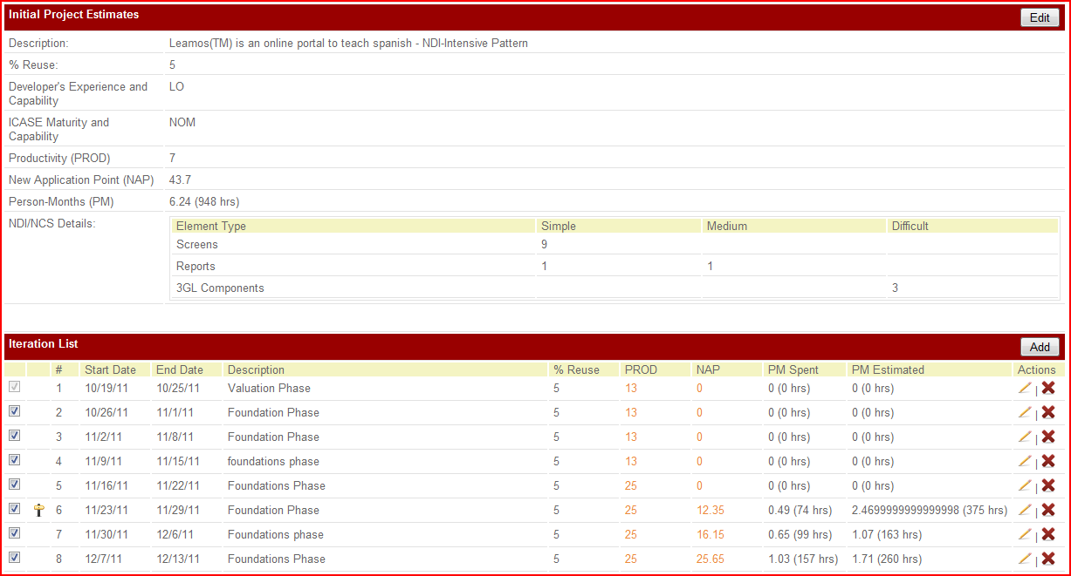

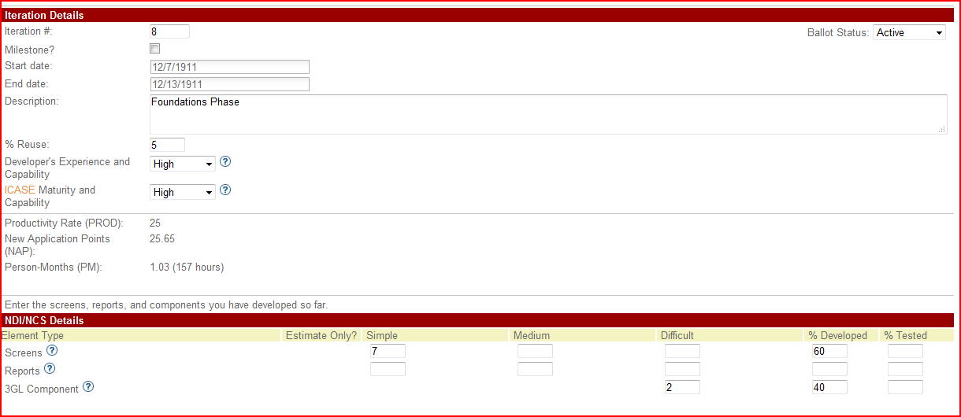

Estimations for modules requiring detailed architecture are done using COCOMO II scale drivers in the COTIPMO tool as below:
Table 11: COCOMOII Scale Driver
Scale Driver | Value | Rationale
PREC | HI | Main tasks are the conversion of existing flash videos to HTML5 and developing an interactive sales website using PHP. There are several sales web sites already developed today using HTML5 and PHP.
FLEX | NOM | We have to enhance the current system and add some new functionality. The languages for the development and the requirements will mostly remain the same as stated in the proposal. We are migrating from one version to the newer version.
RESL | HI | RESL is High because the risk management plan captures most of the critical risk items on a general basis, many of the risks are already known and will be mitigated. We are following ICSM approach where we are doing high risk mitigation.
TEAM | HI | Most of the project team members are located in the same area and have ease of access to each other and with customers, maintainers, and IVV&V through phone calls, emails and conferencing. Users will be using the system online or in a classroom where they have access to internet
PMAT | NOM | Project maturity, in terms of process followed and capabilities falls in CMM Level 2.The process is managed in accordance with agreed metrics.

Table 12: COCOMOII Cost Driver for Password Recovery Module
Cost Driver | Value | Rationale
RELY | NOM | Losses due to software failure will be moderate, will not cause much harm, and will be easily recoverable.
DOCU | LO | Not much documentation is required for this module.
CPLX | NOM | The project will mostly be issuing simple queries to the backend database and display results on web pages.
TIME | NOM | The system is expected to use about 50 to 60% of available execution time.
PVOL | LO | Major changes required every 12 months or longer time period.
ACAP | NOM | The analyst working on the development of the current system has a nominal grip over analysis and design capability.
PCAP | NOM | The development team has nominal programming capability.
PCON | NOM | Personal continuity is nominal as some of the on campus students might leave after this semester.
APEX | NOM | Application Experience is Nominal as most developers have about a year of experience in developing such software system.
LTEX | LO | LTEX is low as the developers have less experience on working with the language and tool to be used.
PLEX | LO | Platform Experience is low as the developers don’t have much experience working on Moodle, PHP, or HTML5.
TOOL | LO | Team has very little experience working with development tools for PHP, HTML5, MySQL and prototyping tools like Balsamiq.
SITE | VHI | Collocation: Same City  Communications: Wideband electronic communication
SCED | NOM | The required time is given for system development. The schedule compression ratio is 100% of the nominal.

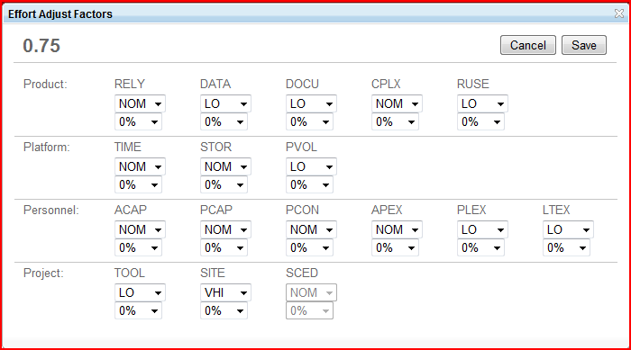
Table 13: COCOMOII Cost Driver for Data Migration Module
Cost Driver | Value | Rationale
RELY | NOM | Losses due to software failure will be moderate, not causing much harm and will be easily recoverable.
DOCU | LO | The Documentation required for this module is low.
CPLX | NOM | The project will be migrating data from one database to another linearly.
TIME | HI | The system is expected to be up and running for about 80% to 90% of available execution time.
PVOL | NOM | Major changes required every 12 months or longer as the new versions of Moodle, MySQL get released once in a year.
ACAP | NOM | The analyst working on the development of the current system has a nominal grip over analysis and design capability.
PCAP | NOM | Development team has nominal programming capability as they have on average 1 year of software system development experience
PCON | NOM | Personal continuity is nominal as some of the on campus students will leave after this semester.
APEX | NOM | Application Experience is Nominal as the developers have about a moderate experience in creating and migrating the database system.
LTEX | LO | LTEX is low as most of the developers have only about 6 months of experience working with database systems.
PLEX | LO | Platform Experience is Low as most developers have less experience working with MySQL.
TOOL | HI | Developers have a good experience working with database tools and debugging database queries.
SITE | VHI | Collocation: Same City  Communications: Wideband electronic communication
SCED | NOM | The required time is given for system development. The schedule compression ratio is 100% of the nominal.

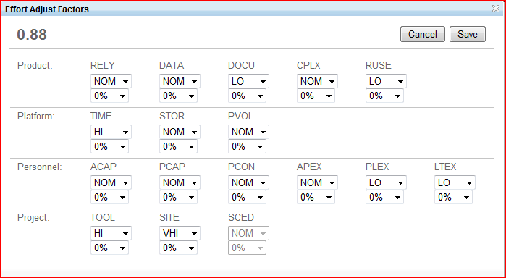

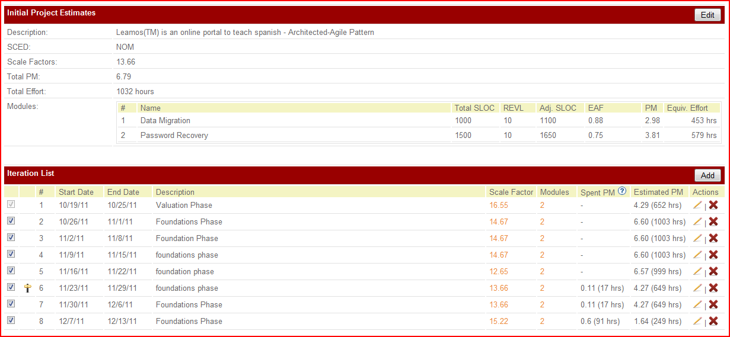
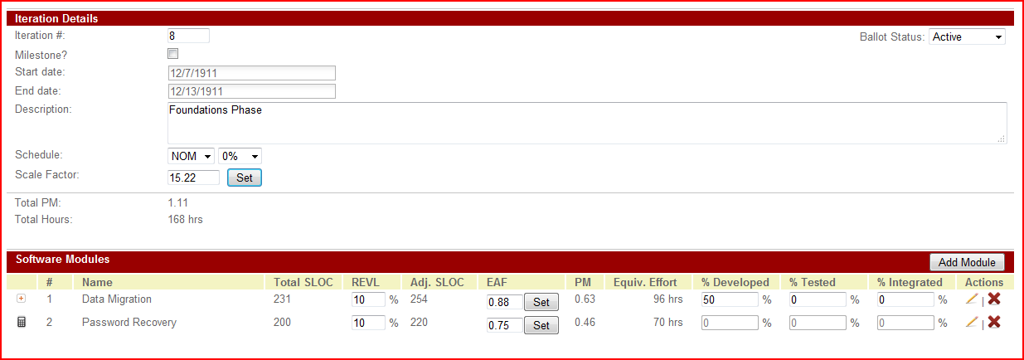

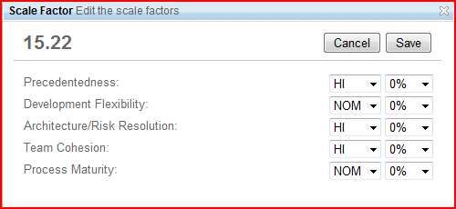

NDIs: Moodle, CourseMerchant, Flash to HTML5 converter
Programming Languages: PHP, HTML5
Database: MySQL

